Experiment

Design Dual led chaser lights

Circuit Diagram

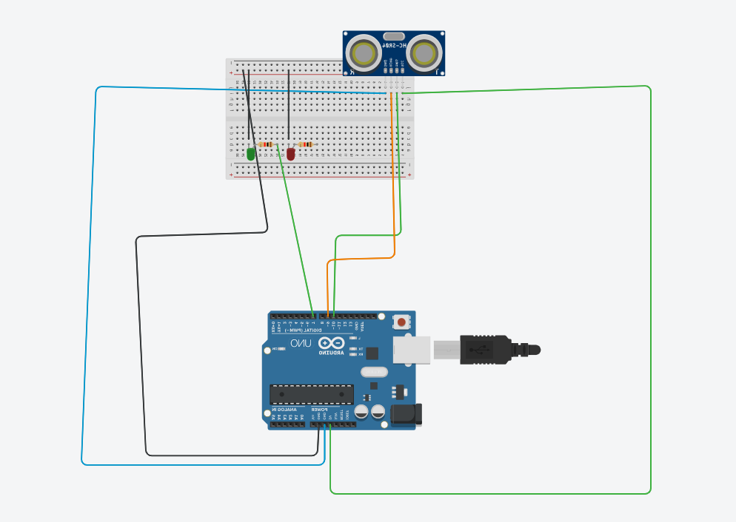

**Theory**

**Concept Used :** This Is The Circuit Of A Simple Led Chaser. The Leds Lights One By One For A Period Of 1second And The Cycle Repeats Giving The Running Light Appearance. The Circuit Uses Two Ics (One Is 555) To Drive The Leds.

**Learning & Observations: :** From this experiment we observe that led blinks at different frequency and patterns means that led gets high and low after certain delays and pair of leds will go high and low at same time (such as in experiment we saw that led is delay for an interval of 1000ms and glowing with different patterns).

**Problems & Troubleshooting :-**

1)Some Of The Leds Were Not Working

>> Place All Led In Correct Order(Anode And Cathode)

**Precautions:-**

1) Check All The Connections.

2) Check All The Devices With Multimeter Whether They Are Working Or Not.

3) Make Proper Series Or Parallel Circuits.

4)Place All Led In Correct Order

**Learning Outcomes**:-

1)From This We Can Make Led To Glow In Different

Pattern.

2)Gets Hands On Ardiuno Board .

3) Led Chasing Patterns With The Help Of Ardiuno.